**Evaluating Management Strategies for Atlantic Bluefin Tuna**

**Report 1 (Draft)**

November 2014

SHORT-TERM CONTRACT FOR MODELLING APPROACHES: SUPPORT TO BFT

ASSESSMENT (GBYP 02/2014) OF THE ATLANTIC-WIDE RESEARCH PROGRAMME ON

BLUEFIN TUNA (ICCAT-GBYP – Phase 4)

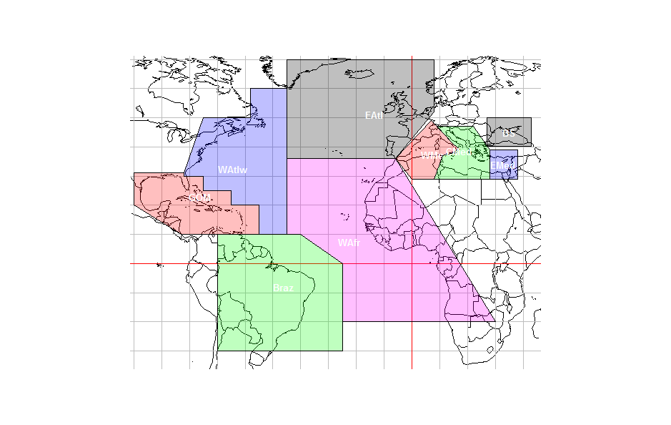

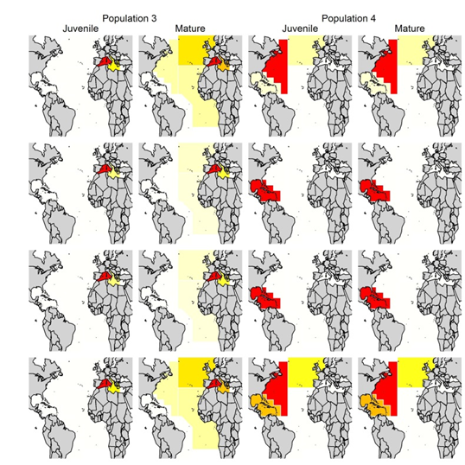

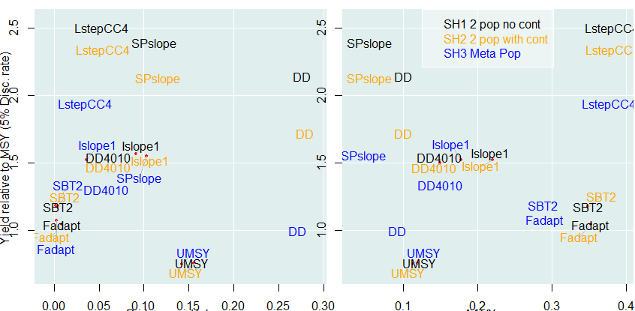

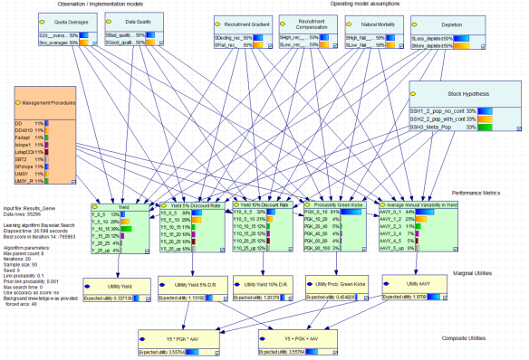

|  |  |  |
| --- | --- | --- |
| Tom Carruthers[1] | Laurence Kell[2] | Campbell Davies[3] |
| UBC | ICCAT | CSIRO |

**Executive Summary**

We describe a preliminary MSE for Atlantic Bluefin Tuna (ABT) that can be used to evaluate management procedures over a wide range of ecological, data collection and management hypotheses. The MSE design makes use of Object-Oriented Programming (OOP) to improve development efficiency and organisation.

A set of operating models were defined that encompass credible sub-population scenarios for the eastern Atlantic stock and the core uncertainties regarding ABT population dynamics. A series of management procedures (MPs) were tested and incorporated in the MSE framework that include simple stock assessments and rules used in the management of southern bluefin tuna.

A set of 55 thousand simulations were identified that covered the core uncertainties in addition to alternative data quality levels and quota overages. In this report we present the main results of the preliminary ABT MSE and introduce Bayesian Belief Networks as a tool in making ABT MSE outputs accessible to a wider group of stakeholders. MP performance was evaluated with respect to metrics that have been previously identified for ABT.

Our early results indicate that alternative stock-structure hypotheses may determine management performance as strongly as conventional sources of uncertainty such as population growth rate, recruitment and natural mortality rate. The effect of increasing sub-population structure was often counter-intuitive which underlines the important role of simulation evaluation of MPs. Simple delay-difference assessments appeared to outperform the other MPs under most circumstances.

In this report we provide a detailed description of the preliminary operating model structure. We discuss the preliminary ABT MSE results, the limitations of the current MSE design and highlight areas for future development. We also report on progress with respect to project deliverables.

Contents

1 Introduction 4

2 Designing of an MSE framework for Atlantic bluefin tuna 5

2.1 Object – Oriented programming (OOP) 5

2.2 The structure of the preliminary ABT MSE 5

2.3 Operating model population dynamics 7

2.4 Operating model fleet dynamics 8

2.5 Software 8

3 Scenarios for a preliminary MSE for Eastern Atlantic bluefin tuna 8

3.1 Overview 8

3.2 Ecological/biological factors 9

3.3 Implementation and observation models 11

3.4 Management procedures 11

3.5 Performance diagnostics 12

3.6 Configuration of preliminary analysis 13

4 Results of preliminary MSE 13

4.1 Drivers of performance: the role of MPs, operating model assumptions, observation and implementation models. 13

4.2 Performance trade-offs 15

4.3 Sensitivity analysis / value of information 17

5 Bayesian belief networks 17

6 Discussion 19

6.1 Preliminary MSE results 19

6.2 Future MSE development 19

7 Progress relative to deliverables 20

7.1 Design document (D1) 21

7.2 Summary of alternative Management Procedures (D2) 21

7.3 MSE demonstrator (D3) 21

8 References 21

9 Appendix 24

9.1 Object classes and attributes (slots) 24

9.2 Operating model equations 27

9.2.1 Population dynamics 27

9.2.2 Fishing dynamics 28

9.2.3 Movement and spatial distribution 30

9.3 An example run of the demonstration MSE 31

# Introduction

The Atlantic-Wide Research Programme on Bluefin Tuna (GBYP) aims to develop a new scientific management framework by improving data collection, knowledge of key biological and ecological processes, assessment models and management. A critical component of the GBYP is the construction of a robust advice framework consistent with the precautionary approach (GBYP 2014).

Management Strategy Evaluation (MSE) offers a solution that is increasingly applied in the management of fisheries (Cochrane et al. 1998, Butterworth and Punt 1999). Figure 1 provides an illustration of a possible MSE for Atlantic bluefin tuna. MSE differs from stock assessment in that detailed fishery data are used to condition an Operating Model (OM); a simulation model that represents plausible hypotheses about fishery and population dynamics. These simulations are then used to tune and evaluate procedures for updating management recommendations that are typically simpler than a conventional stock assessment. These rules are referred to as Management Procedures (MP) and generally operate on recent information regarding trends in abundance and catch data. Instead of using stock assessment as the primary source of management advice, the MSE approach makes routine management decisions using MPs while the operating model is updated to accommodate new data.



**Figure 1**. A possible MSE for Atlantic bluefin tuna.

MSE can add stability to the management decision process by first identifying realistic management objectives through stakeholder participation followed by a thorough evaluation of trade-offs achievable under alternative harvest strategies when accounting for different sources of uncertainty (e.g. Rockmann et al. 2012). MSE can also be used to guide the scientific process by identifying where the reduction of scientific uncertainty will improve performance in achieving management objectives and so help to ensure that expenditure is prioritised to provide the best research, monitoring and enforcement (Fromentin et al. 2014). While a stock assessment assumptions may vary over time due to the expert judgement of scientists (Hilborn, 2003) that can have impacts on management recommendations, the MSE paradigm is intended to instil greater constancy. Additionally since the MSE approach is simulation based it should detect overly complex assessment approaches (management procedures) that can lead to biased management recommendations. This is important as there is increasing evidence that simple MPs can perform as least as well as conventional stock assessments (Geromont and Butterworth 2014b)

In recognition of the potential benefits of MSE for Atlantic bluefin tuna management, the 2013 meeting of the Bluefin Stock Assessment Methods working group (Gloucester, MA; SCRS 2013) recommended Management Strategy Evaluation (MSE) as an approach to building a robust advice framework. Constructing a fully-featured MSE can be broken down into prerequisites and tasks. Two important prerequisites include agreement on performance measures (e.g. long-term stability in yield, probability of underfished status subject to underfishing, Leach et al. 2014, Levontin et al. 2014) and identification of axes of uncertainty for the operating model (e.g. spatial structure, temporally varying growth, Kell et al. 2012, Kell 2014, Fromentin et al. 2014). The most important tasks include the acquisition and processing of data to inform the operating models, the programming of the operating models and the identification and implementation of a range of candidate management procedures (i.e. Carruthers et al. 2014b).

Atlantic bluefin tuna (*Thunnus thynnus*) is an ideal candidate for MSE because a range of data are available to support various stock mixing and sub-stock structure hypotheses that are likely to determine the success of candidate management procedures. For example Arrizabalaga et al. (2014) identify 5 distinct stock hypotheses that include multiple sub-populations for the Eastern stock. Additionally, MSE may be particularly useful in progressing Atlantic bluefin tuna science by quantifying value of information: the performance of a management procedure may be characterized in terms of the uncertainty in inputs leading to the identification of the most critical information gaps (e.g. stock mixing, number of genetically distinct stocks, temporal shifts in maturity or growth).

In this report we describe the development and testing of a preliminary MSE framework for Atlantic bluefin tuna (Section 2). We describe a preliminary set of simulation scenarios in order to demonstrate the functionality of the MSE framework (Section 3). The central results of these preliminary simulations are presented in Section 4 and include a summary of the main sensitivities, MP performance trade-offs and value-of-information analysis. In Section 5 a demonstration Bayesian belief network (a type of inference diagram) is presented that allows for rapid summarization and dynamic investigation of the MSE results by a wide range of stakeholders. The implications of the preliminary results are discussed in the context of wider management considerations in Section 6 which also includes a summary of possible future MSE developments and research priorities. We summarize progress with respect to core project deliverables in Section 7.

# Designing of an MSE framework for Atlantic bluefin tuna

## Object – Oriented programming (OOP)

In order to maximise flexibility and minimize development time we adopt an object-oriented programming (OOP) approach. OOP involves the definition of objects that are data structures with a variety of *attributes* for the organization of data and functions. For example a stock object may have attributes for the name of the species, catch data and natural mortality rate. In this case we have defined an *object class* ‘stock’ with three attributes. The advantage of the OOP approach is that standard functions, referred to as *methods*, may be developed that will operate on any given instance of an object of a particular class. For example a stock assessment method applied to any given stock object.

OOP is particularly appropriate for MSE development because of the hierarchical, multiple scenario nature of MSE. For example MSE may require a standardized data input to an empirically fitted operating model (an object class), an empirical operating mode (a method), graphical representation of the fitted operating model (a method), observation error scenarios (an object class), a range of implementation error models (a function class), the range of candidate management procedures (methods), etc.

## The structure of the preliminary ABT MSE

The preliminary ABT MSE includes several object classes, methods and function classes that are listed in Table 1. The relationship between the object classes and function classes is illustrated in Figure 2.

The operating model may be defined by either a user-specified definition object (*OMd*) or an empirically fitted assessment model or a combination of both. The rationale for the ‘*OMd* to *OM*’ approach was to create a rapid means of investigating alternative stock hypotheses and MP performance without having to fit a detailed assessment model to data which was beyond the scope of this preliminary MSE. The *OMd* is pseudo-empirical in the sense that it includes population parameter inputs, stock size and depletion estimated by recent stock assessments (SCRS 2012). Additionally the ‘*OMd* to *OM*’ step allows for the development of a fully featured MSE framework ahead of the more intensive process of empirical OM testing and conditioning.



**MSE**

**Figure 2**. The MSE design.

**Table 1.** The object classes, methods and function classes of the preliminary ABT MSE

|  |  |
| --- | --- |
|  | |
| **Object classes** | |
| *OMd* | (Operating Model definition) User specified inputs can completely define an operating model |
| *OM* | (Operating Model) A specified OM inc. all sampled parameters and calculated reference points |
| *Obs* | (Observation error model) User-specified levels of imprecision and bias for the inputs to MPs |
| *MSE* | (Management Strategy Evaluation) Summary of MSE simulations including results |
|  |  |
| **Methods (core)** | |
| new(*OM*) | Create new instance of an operating model |
| new(*MSE*) | Create a new instance of an MSE |
|  |  |
| **Methods (ancillary)** | |
| plot(*OMd*) | Plot the area definitions of the OMd object |
| plot(*OM*) | Plot the spatial distribution implied by the movement of the OM object |
| summary(*MSE*) | Summarize the results / performance of the MSE |
|  |  |
| **Function classes** | |
| Imp | (Implementation error model) functions that control mismatch between fleet dynamics and management recommendations |
| MP | Management procedures (e.g. simple algorithms or assessments paired with harvest control rules) |
|  |  |

The *OMd* object class is a concise summary of ranges of inputs for various parameters (for a full description of all the attributes of the *OMd* object and other objects see Appendix 9.1). For example one attribute is the vector of mean natural mortality rate by age and a possible range in natural mortality rate. Because the *OMd* object contains a random seed attribute, this very small file (typically less than 35KB in size) may be easily passed among users from which ultimately the same MSE results can be obtained.

The *OM* object class is a full description of all operating model variables and reference points (e.g. sampled natural mortality rate, sampled fishing mortality rate trajectory over time). These are values for parameters and variables (e.g natural mortality rate current fishing mortality rate) as opposed to ranges as in the *OMd* object. The construction of the *OM* object is computationally intensive and includes the calculation of MSY reference points and optimization for fleet specific catchability coefficients that match user-specified stock depletion. By separating this computation from the rest of the closed-loop simulation, new forward projections may be carried out without having to recalculate reference points. Since the central attributes of the *OM* object have a dimension for simulation number, any input can be replaced by the outputs of an empirically fitted operating model. For example these could be posterior samples of natural mortality rate, stock recruitment compensation, numbers at age or a grid of assumptions for robustness trials (e.g. the MSE of Southern Bluefin Tuna, CCSBT 2011). *OM* objects may also be saved, exchanged among users and used as reference cases for future MSE work.

The *Obs* object class contains the parameters of the observation model. These control the quality of data generated by the operating model that is used by the management procedures (for example bias in estimates of natural mortality rate, precision and bias in historical catches). Since the performance of various MPs may be strongly affected by the quality of their respective data inputs, the observation model is often amongst the most important factors contributing to the performance ranking of MPs.

The *Imp* function class controls how well management recommendations are followed and can simulate a range of phenomena from overages to effort reductions at low catch rates. Implementation models could include maximum fishing mortality rates, declines in fishing effort with expected catch rates (response to declining profits), persistent quota overages or missed quota.

The *MP* function class are management procedures that are the focus of the MSE simulation testing. These represent the complete process from data to management recommendation that may include simple algorithms based on trajectories in catch rates to complex data filtering methods linked to detailed stock assessment models with harvest control rules.

The *MSE* object class stores all the outputs of the MSE closed-loop simulations and has attributes for variables such as population numbers, movement, mortality rate, fishing selectivity, exploitation rate and catches. This object is generally large (>50Mb) and is the focus of a range of methods for summarizing MSE results.

## Operating model population dynamics

The operating model is structured by age, space, sub-year and population (the equations of the population dynamics model are included in Appendix 9.2.1). The operating model includes movement by population, age and sub-year allowing for multiple sub-population hypotheses, seasonal movement, ontogenetic movement and aggregation by mature fish in spawning locations. Natural mortality rate, growth, maturity and recruitment are also specific to population and may be time varying. This allows for the evaluation of key hypotheses for ABT including changes in recruitment strength and natural mortality rate over time (Levontin et al. 2014).

**Table 2.** The variables of the population dynamics model. ‘Structured by simulation’ indicates that the MSE was designed to operate on multiple scenarios for a particular variable. Population refers to an individual breeding population that could be a sub-population of the eastern stock spawning in the Mediterranean for example.

|  |  |
| --- | --- |
| **Variable** | **Structured by:** |
| Natural mortality rate | Simulation, population, age, year |
| Movement | Simulation, population, age, sub-year |
| Maturity | Simulation, population, age, year |
| Recruitment anomalies | Simulation, population, year |
| Growth rate | Simulation, population, year |
| Recruitment compensation | Simulation, population |
| Stock size (unfished recruitment) | Simulation, population |
| Depletion (biomass relative to unfished) | Simulation, population |

## Operating model fleet dynamics

The operating model can account for the exploitation of multiple fleets with time varying effort (see Appendix 9.2 for equations). Fleets were modelled that had temporally constant fishing efficiency, spatial targeting and age-selectivity. This preliminary fleet dynamics model either allows the fleet to maintain its current spatial distribution or alternatively to dynamically alter its spatial distribution relative to vulnerable biomass.

**Table 3.** The variables of the fleet dynamics model. ‘Structured by simulation’ indicates that the MSE was designed to operate on multiple scenarios for a particular variable.

|  |  |
| --- | --- |
| **Variable** | **Structured by:** |
| Effort | Simulation, fleet, year, sub-year |
| Spatial targeting | Simulation, fleet |
| Fishing efficiency | Simulation, fleet |
| Age selectivity | Simulation, fleet, age |

## Software

The MSE framework is implemented in the statistical environment R (R core team, 2014) which is freely available, provides OOP through S4 classes, includes a wide range of presentation tools and provides support for cluster computing.

# Scenarios for a preliminary MSE for Eastern Atlantic bluefin tuna

## Overview

Papers summarising the central uncertainties in stock assessments Fromentin et al. (2014) and the core uncertainties for MSE robustness trials (Levontin et al. 2014) have focused on population structure, natural mortality rate, population growth and recruitment. For the purposes of this MSE we use these as principal ecological/biological factors over which to evaluate the performance of MPs (Table 4). Following Levontin et al. (2014) and Carruthers et al. (2014) we also add scenarios for implementation error (catch under-reporting), observation models that control data quality and stock depletion (spawning stock biomass relative to unfished). Based on the analysis of Carruthers et al. (2014b) we identify eight MPs and evaluate their performance over each combination of factor levels.

**Table 4.** The factors and levels of the factorial MSE design. BC refers to the parameterization of the recent ‘Base Case’ stock assessment (SCRS 2012). In combination, these factors represent a total of 192 sets of assumptions.

|  |  |  |  |  |  |  |
| --- | --- | --- | --- | --- | --- | --- |
| **Stock structure** | **Natural**  **mortality**  **rate** | **Recruitment**  **Compen-**  **sation** | **Recruitment**  **trajectory** | **Implement-**  **ation**  **bias** | **Data**  **quality** | **Depletion** |
| SH1 (Two pop.  no contingents) | Low  (80% BC) | Low  (0.28-0.52) | Flat  (0% y-1) | Accurate  (100% quota) | Good | Low  (2.5-17.5%) |
| SH2 (Two pop.  with contingents) | High  (125% BC) | High  (0.44-0.81) | Declining  (-0.5% y-1) | Overage  (120% quota) | Bad | High  (5%-40%) |
| SH3 (Meta-  population) |  |  |  |  |  |  |

## Ecological/biological factors

We identify three levels of the factor stock structure that provide alternative sub-population hypotheses for the Eastern Atlantic stock (Arrizabalaga et al. 2014, Figures 3-5), two levels of the natural mortality rate factor that are 4/5 and 5/4 the base case stock assessment natural mortality rate at age (SCRS 2012), two levels of recruitment compensation (population growth) that specify different ranges for steepness of the Beverton-Holt stock-recruitment curve (based on the inferred S-R curves of recent assessments, SCRS 2012) and two levels of temporal trajectory in recruitment that include either a flat trend or a declining trend (1/2 % y-1).

A core finding of previous MSE research (e.g. Carruthers et al. 2014a) is that starting level of stock depletion can have a large impact on the relative performance of MPs. Therefore two levels of stock depletion are also considered that represent the upper and lower ranges estimated from recent stock assessments (SCRS 2012).

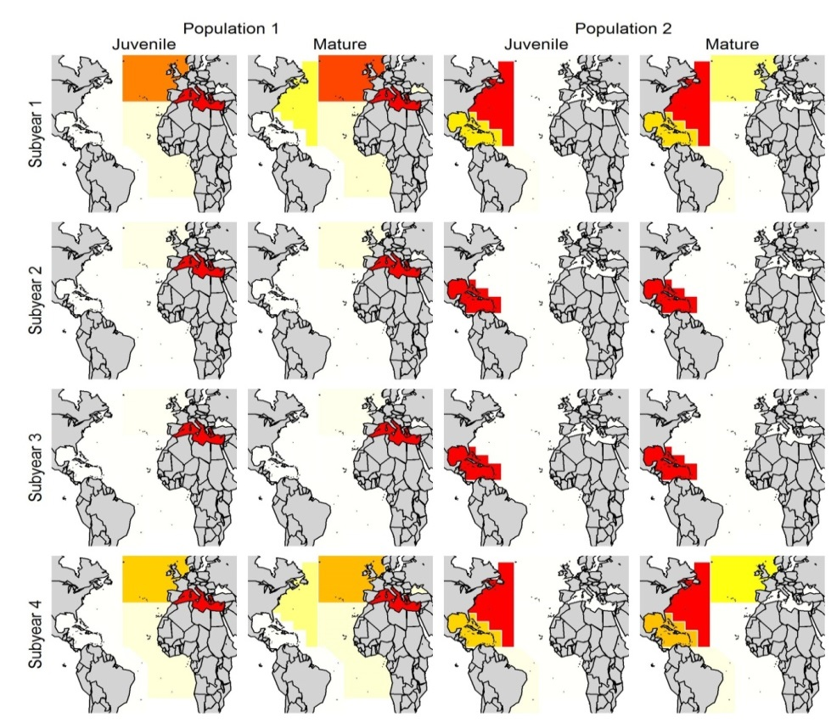

**Figure 3**. The two population model with no sub-populations (Arrizabalaga et al. 2014, SH1)



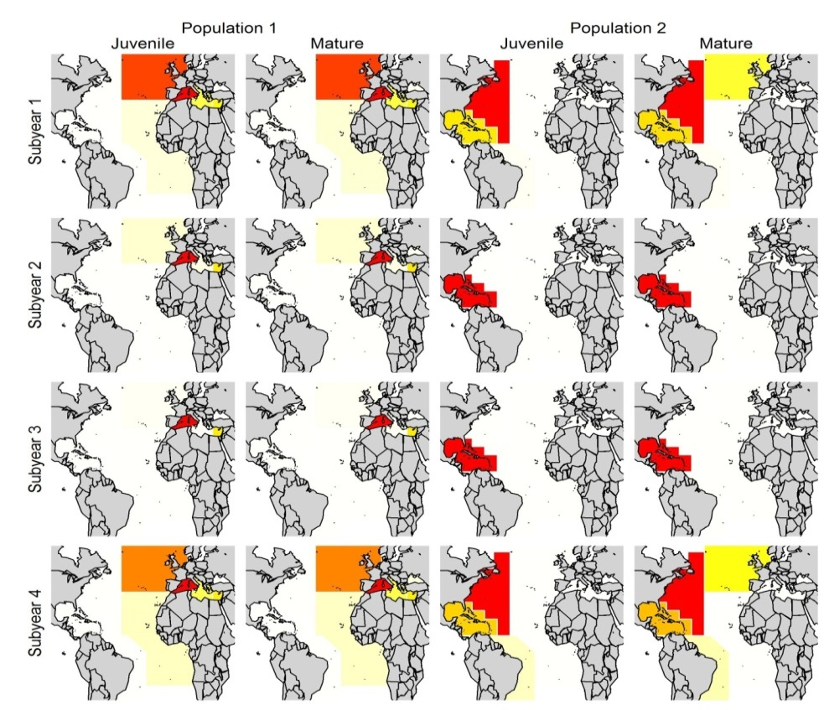

**Figure 4**. The two population model with contingents (Arrizabalaga et al. 2014, SH2)





**Figure 5**. The metapopulation model (Arrizabalaga et al. 2014, SH3). A model with three separate Mediterranean sub-populations.

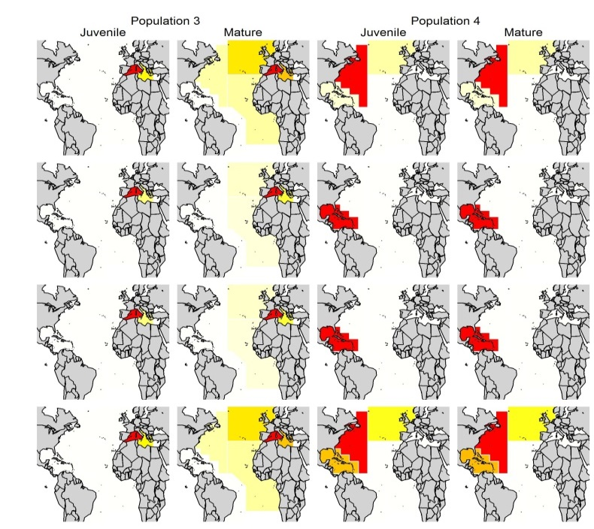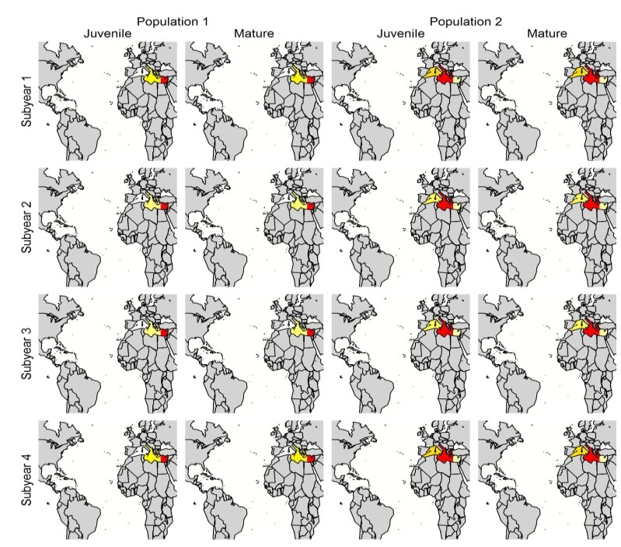

## Implementation and observation models

The preliminary MSE includes two levels of implementation bias (accurate and 20% quota overages) to evaluate the relative importance of potential overages.

Management procedures can make use of a wide range of fishery data that are likely to be subject to observation error and potential biases. For example extended survivorship analysis (XSA, Shepherd 1992) requires input values for natural mortality rate, catch-at-age data and a relative abundance index, whereas slope MPs (e.g. ‘Islope1’, Geromont and Butterworth 2014b) makes use of just recent CPUE and aggregated annual catch data. It follows that the quality of these data will affect the relative performance of the respective MPs. It follows that it is important to recreate credible bias and imprecision in data. In this preliminary MSE we include two observation error models that simulate relatively bad and relatively good quality data (Table 5).

Data were simulated from observation models that could include both bias (e.g. observations of historical catches that are 10% over those actually taken) and imprecision (e.g. observation error or ‘noise’ in annual estimates of catch)(Table 5).

**Table 5.** The two observation models used to generate two levels of relative data quality ‘good’ and ‘bad’.



## Management procedures

Based on the results of Carruthers et al. (2014b) we selected a shortlist of 8 management procedures to investigate in this preliminary MSE (Table 6). These include the index slope MP applied to Southern Bluefin Tuna (*SBT2*, CCSBT 2012, Kell et al. 2014), the index slope and average catch MPs (*Islope1* and *LstepCC4*) of Geromont and Butterworth (2014a), the adaptive FMSY MP (*Fadapt*) that is a hybrid of Maunder’s (2014) surplus production seeking MP (*SPslope*)*,* and fishing at a fixed fishing mortality rate (*UMSY*).

We also include a delay-difference stock assessment *DD,* fitted to historical catch and CPUE data. A second version of the delay-difference model includes the 40-10 harvest control rule (*DD4010*). Under the 40-10 rule the stock is not fished when stock size is below 10% unfished biomass and fished at FMSY above 40% of unfished biomass. Between 10% and 40% unfished levels exploitation rate follows a linear increase from 0 to 100% FMSY.

**Table 6.** The equations of the 8 candidate management procedures. *Q* is a quota recommendation, *C* is a total annual catch observation, *B* is an absolute annual biomass estimate, *I* is an annual relative abundance index or catch rate (CPUE) observation, *R* is an estimate of recruitment strength, *y\** refers to the first year in which the MP was implemented, *MSY, FMSY* and *UMSY* are catches, instantaneous exploitation rate and harvest rate at Maximum Sustainable Yield subject to imperfect information.

|  |  |
| --- | --- |
| **MP Name** | **Quota calculation** |
| **SBT2**  CCSBT 2011 | $Q_{y}={\frac{1}{2}C}_{y-1}+δMSY$, $δ=\left\{\begin{matrix}Δ^{7/4} & Δ<1 \\ Δ^{1/4} & Δ>1\end{matrix}\right.$, $Δ=R^{ave}/R^{hist}$ $R_{y}^{ave}=\frac{1}{5}\sum_{t=y-4}^{y}{R_{t}}$, $R_{y}^{hist}=\frac{1}{10}\sum_{t=y-9}^{y}{R_{t}}$ |
| **Islope1**  Geromont and Butterworth 2014a | ${\overline{Q}}_{y*}=5\sum_{t=y*-4}^{y*}{C_{t}}$ $Q_{y+1}=Q_{y}\left(1+0.4s_{y}\right)$ where *s* is the gradient of log CPUE over the last 5 years |
| **LstepCC4**  Geromont and Butterworth 2014a | $Q_{y+1}=Q_{y}±\frac{1}{20}{\overline{C} }_{y+1}$, $Q_{y*}=0.7{\overline{C}}_{y*}$, ${\overline{C}}_{y+1}=1/5\sum_{t=y-4}^{y}{C_{t}}$ |
| **Fadapt**  Carruthers et al. 2014 | $Q_{y}={\overline{F}}_{y}{\overline{B}}_{y}$, $F_{y}^{try}=F^{L}+{logit}^{-1}\left(W_{y}-G_{y}\right)\left(F^{U}-F^{L}\right)$ $W_{y}=\left\{\begin{matrix}logit\left(\frac{F_{y}^{ave}-F^{L}}{F^{U}-F^{L}}\right) & F^{L}<F_{y}^{ave}<F^{U} \\ -2 & F_{y}^{ave}<F^{L} \\ 2 & F^{U}<F_{y}^{ave}\end{matrix}\right.$  *G* is the slope in *S*, with biomass over the last 7 years, $F^{L}=\frac{FMSY}{2} F^{U}=2FMSY$ |
| **SPslope**  Carruthers et al. 2014 | $$Q_{y}=\left\{\begin{matrix}\left[-0.5\left(B_{y-4}-{\overline{B}}_{y}\right)/B_{y-4}\right]C_{y}^{ave} & Δ^{B}<9/10 \\ \frac{9}{10}S_{y-1} & Δ^{B}>11/10 \\ C_{y-1} & 9/10<Δ^{B}<11/10\end{matrix}\right.$$ $Δ^{B}={\overline{B}}_{y}/B_{y-4}$, $S_{y}=B_{y}-B_{y-1}+C_{y-1}$, $C_{y}^{ave}=1/4\sum_{t=y-3}^{y}{C_{t}}$ |
| **UMSY**  NPFMC 2012 | $$Q_{y}=UMSY∙B_{y}$$ |
| **DD**  Carruthers et al. 2014 | Delay-difference stock assessment fitted to annual catch and catch rate data |
| **DD4010**  Carruthers et al. 2014 | As DD with a 40-10 harvest control rule superimposed |

## Performance diagnostics

Following Leach et al. (2014) we evaluate performance according to three metrics: (1) probability of maintaining the stock in the green Kobe quadrant (F/FMSY <1, B/BMSY>1), (2) magnitude of maximum continuing catch and

(3) Stability of yield. In the absence of a defensible effort dynamics model and economic model it was not possible to include the fourth and fifth performance metrics of Leach et al. (2014) that were stability of effort and maintaining high employment.

Probability of ending in the Green Kobe (PGK) and average annual variability in yield (AAVY) are easily calculated and represent metrics 1 and 3, respectively (Table 7). Maximum continuing catch is more of a challenge because it is important to maintain meaning across simulations that may obtain very different absolute yields due to circumstance other than MP selection (e.g. a depleted stock with low future recruitment versus a less depleted stock with strong future recruitment). In order to maintain comparability among simulations, depletion scenarios, natural mortality scenarios and stock hypotheses we calculate a relative yield metric, which is the average catch obtained by an MP relative to fishing at UMSY given the same simulated conditions. The yield metric was calculated given 0%, 5% and 10% discount rates (Y, Y5 and Y10).

**Table 7.** Performance metrics of this simulation evaluation and their derivation.

|  |  |  |
| --- | --- | --- |
| **Performance metric** |  | **Derivation per simulation** |
| Yield 0% discount rate | Y | $$Y=\frac{1}{n_{y}}\sum_{y=1}^{n_{y}}{C_{y}/\frac{1}{n_{y}}\sum_{y=1}^{n_{y}}{C_{y}^{FMSY}}}$$ |
| Yield 5% discount rate | Y5 | $$Y5=\frac{1}{n_{y}}\sum_{i=1}^{n_{y}}{{{(19/20)}^{y}C}_{y}}/\frac{1}{n_{y}}\sum_{y=1}^{n_{y}}{{(19/20)}^{y}C_{y}^{FMSY}}$$ |
| Yield 10% discount rate | Y10 | $$Y10=\frac{1}{n_{y}}\sum_{y=1}^{n_{y}}{{{(9/10)}^{y}C}_{y}}/\frac{1}{n_{y}}\sum_{y=1}^{n_{y}}{{(9/10)}^{y}C_{y}^{FMSY}}$$ |
| Average annual variability in yield | AAVY |  |
| Probability of Green Kobe | PGK | $$PGK=\left\{\begin{matrix}0 & \frac{B_{ny}}{B_{MSY}}<1 or \frac{F_{ny}}{F_{MSY}}>1 \\ 1 & \frac{B_{ny}}{B_{MSY}}>1 and \frac{F_{ny}}{F_{MSY}}<1 \end{matrix}\right.$$ |
| where *ny* is the number of projected years and *C* are the true simulated catches of an MP *ni* is the number of simulations, *Bny* is the biomass in the final year of the simulations, and *BMSY* is the true simulated biomass at maximum sustainable yield. | | |

## Configuration of preliminary analysis

The preliminary MSE was used to undertake 55,296 simulations composed of 32 replicate simulations for 9 MPs (including the perfect information UMSY MP used to calculate yield) over each combination of the stock hypotheses, observation models, implementation models, initial stock depletion, recruitment compensation, recruitment trajectory and natural mortality rate (192 combinations). Using parallel processing, a single quad-core Intel i7 finished the closed loop simulations in around 20 hours.

# Results of preliminary MSE

## Drivers of performance: the role of MPs, operating model assumptions, observation and implementation models.

Across all simulations, MP selection had the strongest impact on performance with respect to Y, AAVY and PGK (Figures 6 and 7). Of the operating model variables, recruitment compensation (steepness, h), natural mortality rate and stock depletion were the principal drivers of performance differences among methods. The influence of these factors was more pronounced when focusing on one of the better performing MPs such as the delay-difference model (DD, Figure 7). Alternative stock hypotheses generally had little effect on yield but impacted AAVY and PGK in the delay-difference simulations (Figure 7). Simulating 20% overages in quota appeared to have little impact on the performance metrics.

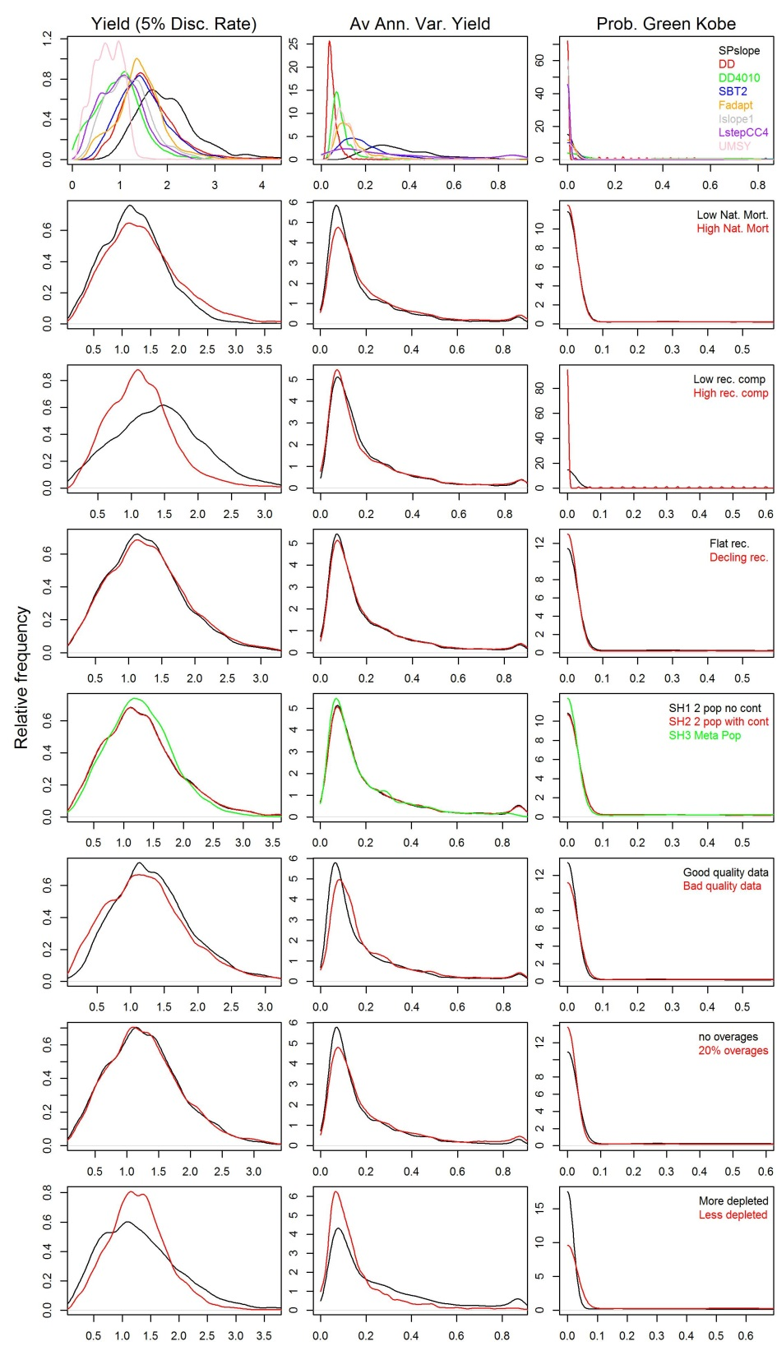

**Figure 6.** The distribution of performance metrics for all simulations separated marginally by the various simulation factors.

Recruitment trajectory had an unexpected impact on the PGK scores for the delay-difference MP (Figure 7). In simulations where recruitment strength was simulated to decline 0.5 % per year the delay difference model was more likely to rebuild the stock leading to higher PGK scores. This is likely due to the estimation of a more depleted stock that can withstand lower fishing rates. Catch recommendations were therefore downward biased to a greater extent than the decline in future productivity due to the downward trend in future recruitment.

The higher resilience (higher PGK scores) of the metapopulation model (SH3) was less surprising when considering the fishing dynamics that were simulated. Since fishing is directed to areas of higher vulnerable biomass and the spatial distribution of the sub-populations are distinct (Figure 5), the fleet moves opportunistically and provides a refuge from fishing for sub-populations as they become increasingly depleted.

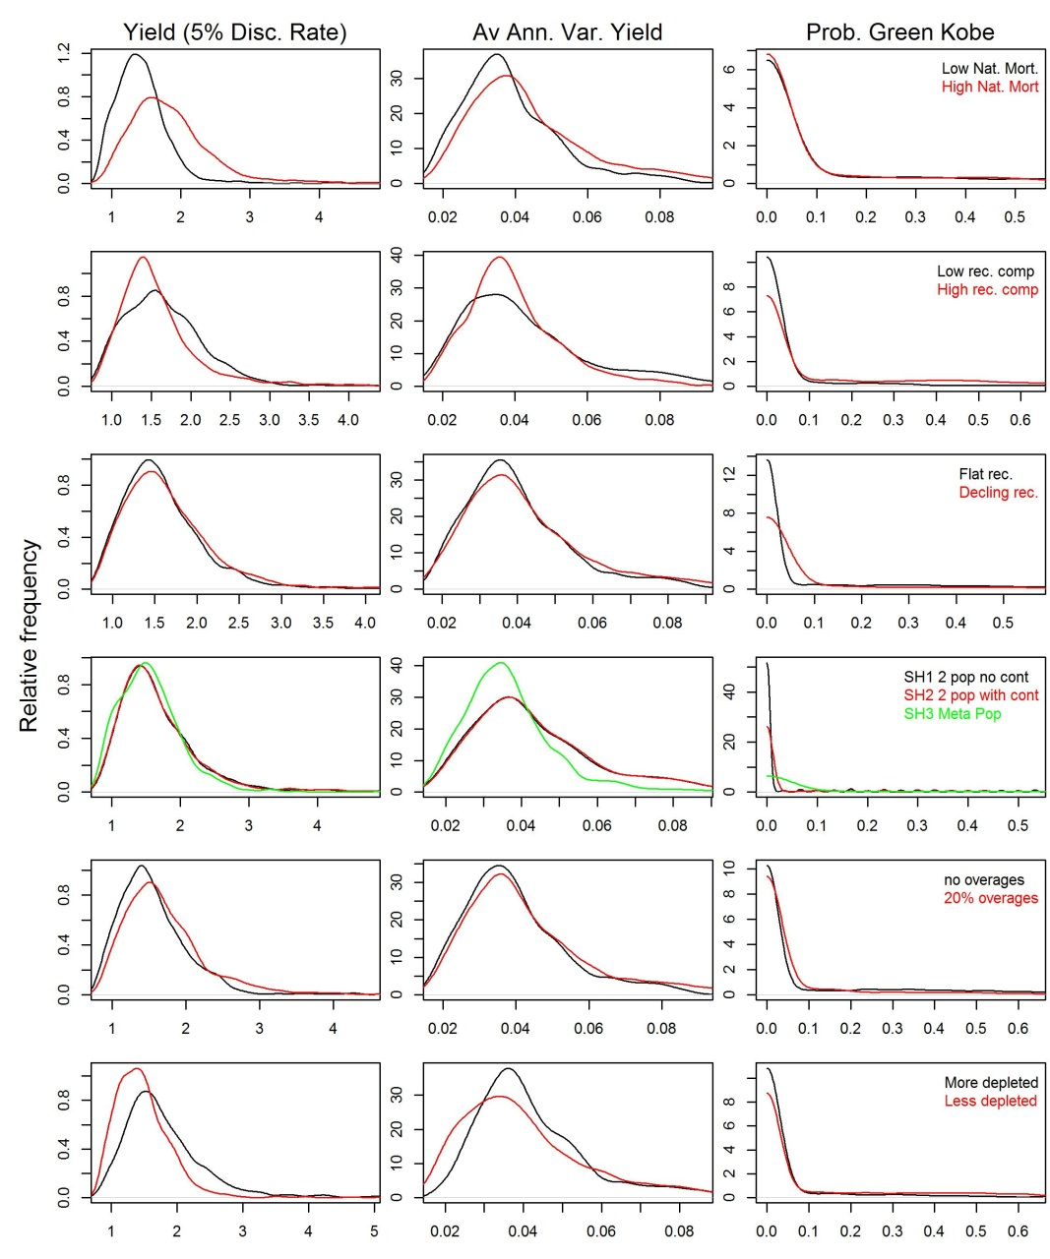

**Figure 7.** The distribution of performance metrics for delay-difference simulations given good quality data separated marginally by the other simulation factors.

## Performance trade-offs

It was possible for MPs to obtain mean yield scores (given a 5% discount rate) that were well above fishing at FMSY levels (perfect information) but this appears to come at the cost of lower PGK scores. There was not a clear trade-off in performance metrics among the MPs and some methods (e.g. DD) outperformed others in all three metrics.

The delay-difference MP appeared to offer the best balance of performance in terms of Y5, PGK and AAVY (Figure 8), however the Y5 metric was much lower compared to other MPs where natural mortality rate and recruitment compensation was high. The delay-difference model performance with respect to Y5 appears to be more sensitive to stock hypotheses than the other MPs (Figure 8).

The LstepCC4 MP performed well in terms of Y5 but less well with respect to PGK and AAVY. SPslope could provide high yields with modest PGK scores and low AAVY. A surprising result was the relatively poor performance of the fixed fishing rate strategy UMSY, which in other simulation evaluations has ranked highly (Carruthers et al. 2014a/b).

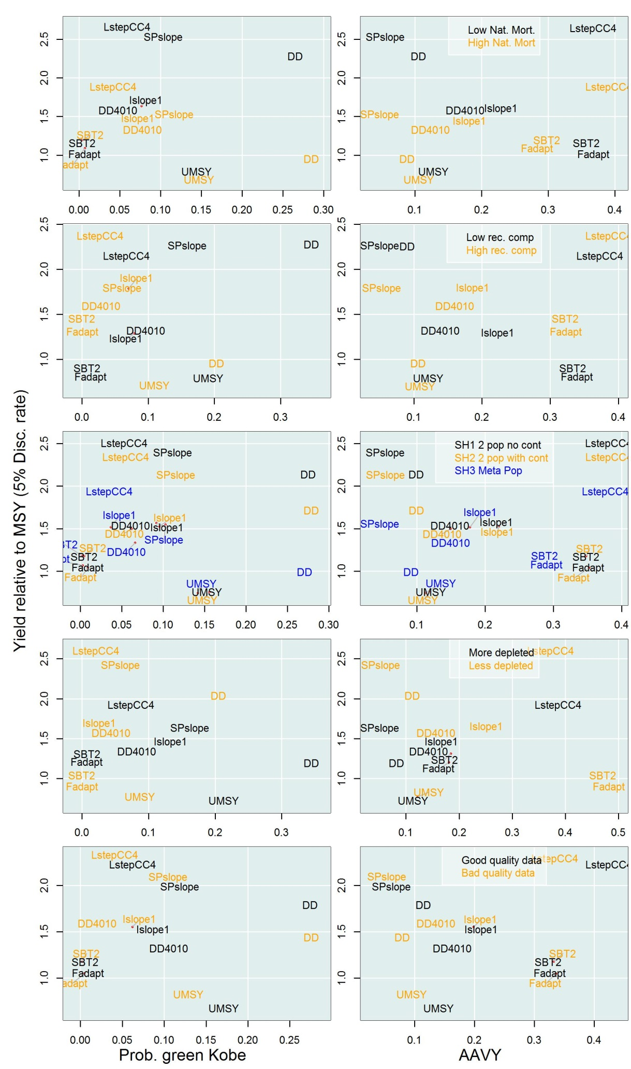

**Figure 8**. The performance of the candidate MPs given different subdivisions of the simulations.

## Sensitivity analysis / value of information

Multiple regression analysis (Tables 8a and 8b) confirms the performance picture presented in Figures 6-8. The lack of significance of the recruitment compensation factor implies covariance with other simulated parameters and requires further investigation. A surprising inclusion in the significant explanatory variables is implementation error which has a relatively minor effect on yield but was found to be significant for all MPs combined (Table 6a) and the delay-difference MP in isolation (Table 6b)

**Table 8a**. Effect of simulation conditions on yield (5% discount rate) across all MPs. The results of a linear model fitted to expected yield. ‘Estimate’ refers to the average difference in yield relative to the UMSY perfect information MP (ie in units of yield of the UMSY MP). Components marked with asterisks had p-values less than 5%. The intercept represents the effect of all level 1 factors combined.



**Table 8b.** As Table 8a but for the delay-difference MP only.



# Bayesian belief networks

The factorial nature of the preliminary MSE analysis is well suited to presentation in a Bayesian Belief Network. BBNs are inference diagrams that represent the connectivity of factors. They can be adapted to include multiple utility functions. Perhaps their biggest potential benefit is that they allow a wider audience to gain an intuition of MSE behaviour by dynamically adjusting assumptions and viewing impacts on utility in real-time.

To demonstrate the possible benefits of this approach we constructed a BBN in the software GeNIe (2014) (Figure 8) which is freely available and provides a range of tools for calculating utility, illustrating sensitivities and determining value-of-information.

This trial BBN includes ‘nodes’ for management procedures, observation and implementation error and the conditions of the operating model. The user can alter ‘evidence’ in the BBN to change the weighting of assumptions to investigate the impact on performance metrics and additive utility functions (similar to Levontin et al 2014).

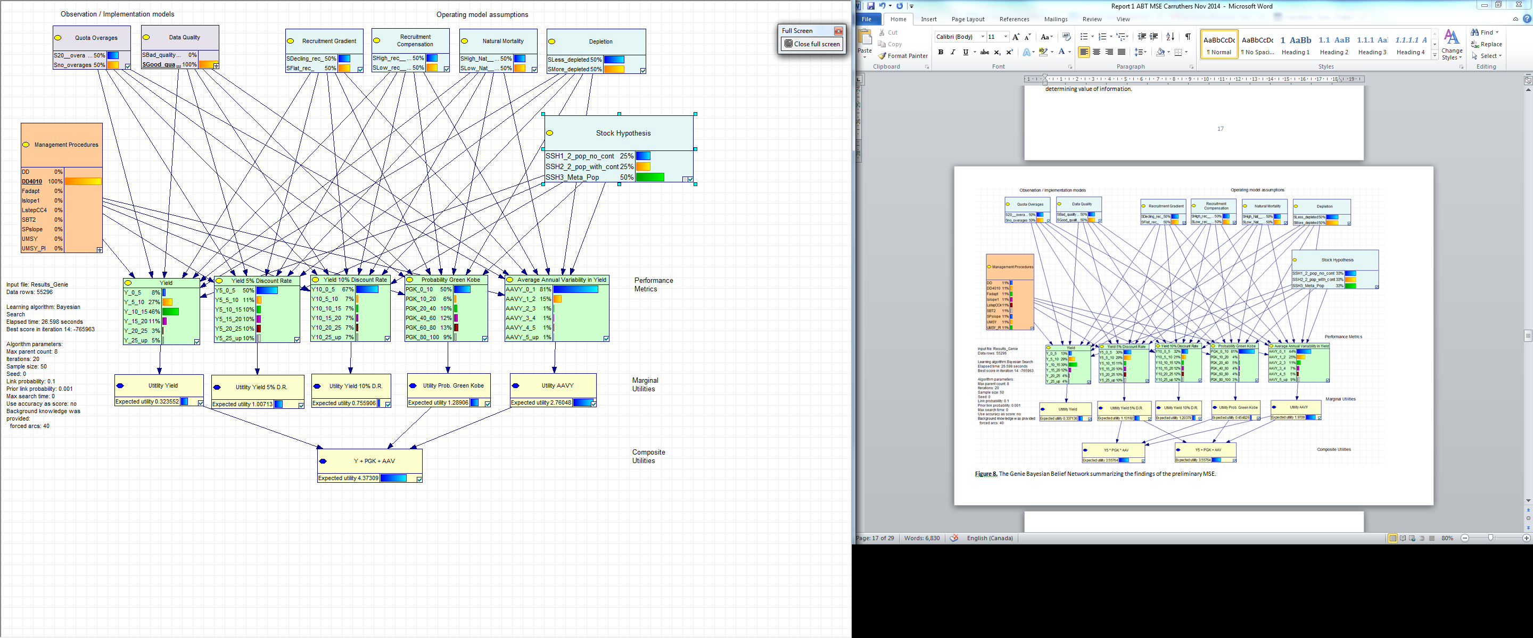

**Figure 8.** A screenshot of the Genie Bayesian Belief Network summarizing the findings of the preliminary MSE.

# Discussion

## Preliminary MSE results

Fromentin et al. (2014) identify population structure, natural mortality rate, population growth and recruitment as the primary sources of uncertainty for ABT. Our early results confirm that alternative stock hypotheses (population structure) may determine the likelihood of meeting management objectives (e.g. probability of green Kobe, PGK) as strongly as alternative hypotheses for natural mortality rate, population growth (recruitment compensation rate) and recruitment (trajectory in recruitment).

Our simulations indicate that sub-population structure can lead to unpredictable results. The metapopulation hypothesis (SH3) was more likely to recover to be underfished and subject to underfishing (higher PGK) than simulations with smaller number of sub-populations. This may be a product of simulating overly simplistic spatial population distribution and spatial fishing dynamics. Nonetheless this result underscores the important role of simulation evaluation in revealing the behavior of complex systems. A similar example was the higher PGK scores of the delay-difference MP for declining recruitment trajectory. The bias in estimated parameters of the DD MP over the 50 year historical simulation was strong enough to counter the future loss in productivity from declining recruitment. Without undertaking closed-loop MSE simulation it is not possible to reveal these often counter-intuitive dynamical properties.

In this analysis we consider MSY reference points and depletion by stock and essentially aggregate all eastern sub-populations when calculating these reference points and related performance metrics. The risk of extinction to subpopulations (relevant only to the meta-population model SH3) is not used in the evaluation of performance and when monitored is likely to reveal added risks to smaller less productive stocks (Kell et al. 2012). An important future step in MSE development is characterizing stakeholder utility with respect to the depletion of one or more sub-populations. Given

Simple stock assessment models such as the delay-difference MP appear to offer the best overall performance. However it should be noted that in future applications many of the other candidate MPs will be tuned to a training set of operating model simulations and may offer substantially improved performance. Simple MPs such as SPslope have provided mixed performance in other simulation studies (Carruthers et al. 2014b). However SPslope appeared to perform much better given the particular performance metrics and spatial dynamics simulated here. This finding suggests that caution should be taken in the wider interpretation of simulation studies particularly if there are large discrepancies in operating model assumptions or defined objectives.

The relative lack of sensitivity to data quality may be a product of observation models that were too similar and did not span a credible range of bias and imprecision in data inputs to MPs. Consultation with experts and more comprehensive simulation of data-gathering protocols is likely to improve the credibility of future observation models. These should include models for aerial survey, catch-composition, microsatellite, genetics and pop-off satellite archival tagging data.

In general, performance was not sensitive to 20% overages in quotas, including yield metrics. This indicates that unless it is substantially larger, implementation bias may be a less critical determinant of management performance than the choice of MP. It should be noted that historical overages and catch under-reporting may have been substantially higher (Fromentin 2009)

## Future MSE development

Amongst the most important future steps in MSE development is the definition of management goals and performance measures to quantify the extent to which those goals have been achieved (Fromentin et al. 2014, e.g. Kell et al. 2013). Interactive tools such as Bayesian belief networks offer stakeholders the opportunity to focus on their core objectives and construct meaningful utility functions. It may be necessary to construct economic models to represent the full range of performance metrics that have been identified for ABT such as employment and inter-annual variability in fishing effort (Leech et al. 2014). A related task is the construction of credible models for fleet dynamics as these are required to model the response in fishing mortality rate to the spatial distribution of the population and the level of stock depletion. The preliminary effort dynamics and implementation error models presented here are overly simplistic and likely to strongly determine the relative performance of the various MPs. In future analyses it may be necessary to allow for time varying age selectivity and changes in fishing efficiency.

The identification of hypotheses that may impact performance was discussed by Fromentin et al. (2014) and our preliminary MSE was designed specifically to accommodate such hypotheses. The next stage is the development and testing of a spatial operating model that may be fitted to the data that are available for ABT. This is technically the most demanding of the tasks required for implementing a full MSE for ABT. A particular challenge is informing statistical models that include multiple sub-stocks. This may require allocating data to sub-stocks based on time, location and other covariates. The processing of up-to-date electronic tagging data and survey data are also priorities for the conditioning of an empirical operating model, although data that are already available in the conditioning of previous spatial models may be sufficient to bracket a range of credible movement scenarios (e.g. Taylor et al. 2011)

Given the body of MSE work that has been carried out for other fish stocks including Southern Bluefin Tuna, there are already a wide range of candidate MPs available. Many of these are easily incorporated in future analyses as they were tested in the peer-reviewed paper that was drafted in parallel to this document (Carruthers et al. 2014b). Since Virtual Population Analysis (VPA) is an assessment that has traditionally been applied to ABT it would have been desirable to test a related MP. In this preliminary MSE a VPA assessment using Fisheries Library in R was investigated. While the MP would operate in over 95% of simulated situations the procedure led to errors in a small fraction of cases. Future testing and development of this MP is necessary to ensure it is sufficiently robust to a range of simulated conditions (for example a stock that has crashed and catches have remained low for several years).

Other MPs that should be considered are statistical catch-at-age models (e.g. Stock Synthesis, Methot and Wetzel 2013) and statistical catch-at-length models (e.g. MULTIFAN-CL, Fournier et al. 2012) that are commonly used to assess other tuna resources. As in the case of the VPA assessment the core challenge is making the more complex MPs robust to a wide range of simulated conditions, that can violate fundamental assumptions of the approaches (e.g. stationary stock productivity, growth, fully mixed stock dynamics).

Many MPs are designed to be tuned to a training set of simulations. This is followed by robustness trials in which frailties in the candidate MPs are revealed with respect to the core uncertainties. The current MSE framework can be easily adapted to include robustness trials by tuning MPs to the empirical operating model (informed by a spatial assessment model for example) and then using the MSE framework to investigate alternative scenarios for the primary sources of uncertainty. Once an empirical operating model has been defined, the preliminary MSE framework can also be used to conduct retrospective tests of performance in which MPs are evaluated given the historical estimates of population dynamics (e.g. Geromont and Butterworth 2014b).

The demonstration Bayesian Belief Network illustrates how new software developments may be used to help a wider range of stakeholders understand and interact with the complex results of an MSE analysis. Future work should investigate other decision theoretic approaches such as dynamic inference diagrams and continuous BBNs such as Hugin Expert. Following feedback from the core modelling steering group it would be beneficial to build the ABT-MSE framework into an R package along with supporting documentation and walkthroughs to maximize the opportunity for stakeholder participation and feedback.

# Progress relative to deliverables

*Develop well documented, object-oriented C++ source code for the operating model consistent with the recommendations of the Modelling Coordinator, ICCAT population dynamics specialist and the Core Modelling Steering Group; as part of this development, the successful bidder shall participate in two documents co-authored with others:*

## Design document (D1)

*A design document that details an object orientated (OO) design with code based on C++ and/or S4 classes for i) a multi-population OM that can be conditioned on a variety of data sets and hypotheses and ii) an Observation Error Model (OEM) that can be used to evaluate different data collection regimes e.g. aerial survey, tagging programs, catch and catch per unit effort (CPUE) and size to age conversions.*

The design of the MSE framework, the relationship of objects, the definition of these classes and their related methods are all detailed in this report. The code for the MSE framework is available at [ABT MSE 2014](https://drive.google.com/folderview?id=0B0HYOP0BN5RPdUYxQzVFcDh3dUE&usp=sharing) including a walkthrough of a typical MSE analysis. If necessary a dedicated MSE design document can be produced.

## Summary of alternative Management Procedures (D2)

*Summary of alternative management procedures including alternative stock estimation procedures with coding requirements and appropriate code, libraries and packages. For example there are a variety of stock assessment methods already coded up and these may need modification to be used within a common MSE framework or adapted to use GBYP data and BFT stock assessment assumptions.*

In collaboration with the Core Modelling Steering Group a simulation evaluation study was carried out on a total of 26 candidate management procedures. The approach and results have been summarized in a draft peer-reviewed paper. The latest version of the draft paper is available at [ABT_MSE 2014](https://drive.google.com/folderview?id=0B0HYOP0BN5RPdUYxQzVFcDh3dUE&usp=sharing) in the subfolder ‘submissions’.

## MSE demonstrator (D3)

*MSE demonstrator for use with stakeholders to illustrate the impact of uncertainty on management objectives and collaboration on a manuscript describing these results*

A streamlined demonstration of the preliminary ABT MSE is available at [ABT_MSE 2014](https://drive.google.com/folderview?id=0B0HYOP0BN5RPdUYxQzVFcDh3dUE&usp=sharing). Users can follow the R walkthrough ‘RScripts/Example script.r’ (see Appendix 9.3). Additionally users may install the GeNIe (2014) software and load the Bayesian Belief Network ‘Genie/ABT_MSE.xdsl’ to investigate the preliminary MSE results.

**Acknowledgments**

This work was carried out under the provision of the ICCAT Atlantic-Wide Research Programme for Bluefin Tuna (GBYP), funded by the European Union, by several ICCAT CPCs, the ICCAT Secretariat and by other entities (see:http://www.iccat.int/GBYP/en/Budget.htm). The content of this paper does not necessarily reflect the point of view of ICCAT or of the other funders, which have no responsibility for it, neither does it necessarily reflect the views of the funders and in no way anticipates the Commission's future policy in this area.

# References

ABT MSE. 2014. R code, demonstrations, belief networks and software available at: <https://drive.google.com/folderview?id=0B0HYOP0BN5RPdUYxQzVFcDh3dUE&usp=sharing>

Arrizabalaga, H., Fromentin, J.M., Kell, L.T., Kerr, L.A., Kimoto, A., Porch, C., Secor, D.H. 2014. Population hypotheses and stock assumptions for North Atlantic Bluefin tuna. SCRS/2014/xxx.

Butterworth, D.S., Punt, A.E., 1999. Experiences in the evaluation and implementation of management procedures. ICES J. Mar. Sci. 56, 985-998.

Carruthers, T.R., Punt, A.E., Walters, C.J., MacCall, A., McAllister, M.K., Dick, E.J., Cope, J. 2014a. Evaluating methods for setting catch limits in data-limited fisheries. Fish. Res. 153: 48-68.

Carruthers, T.R., Kell, L., Maunder, M., Geromont, H., Walters, C., McAllister, M.K., Hillary, R., Kitakado, T., Davies, C. 2014b. Performance Review of Simple Management Procedures. [Drafted as part of this contract]

CCSBT. 2011. Report of the Sixteenth Meeting of the Scientific Committee. Bali, Indonesia. Commission for the Conservation of Southern Bluefin Tuna. Available at: http://www.ccsbt.org/userfiles/file/docs_english/meetings/meeting_reports/ccsbt_18/report_of_SC16.pdf

Cochrane, K L., Butterworth, D.S., De Oliveira, J.A.A., Roel, B.A., 1998. Management procedures in a fishery based on highly variable stocks and with conflicting objectives: experiences in the South African pelagic fishery. Rev. Fish. Biol. Fisher. 8, 177-214.

Fournier, D.A., Skaug, H.J., Ancheta, J., Ianelli, J., Magnusson, A., Maunder, M., Nielsen, A. and Sibert, J. 2012. AD Model Builder: using automatic differentiation for statistical inference of highly parameterized complex nonlinear models. Optim. Meth. Soft. 27 (2): 233-249.

Fromentin, J.M. 2009, Lessons from the past: investigating historical data from bluefin tuna fisheries}, Fish and Fisheries, 10, 2, 197--216, Wiley Online Library.

Fromentin, J-M., Lopuszanski, D. 2014. Migration, residency and homing of Bluefin tuna in the western Mediterranean Sea. ICES J. Mar. Sci. 71(3): 510-518.

Fromentin, J-M., Bonhommeau, S., Arrizabalaga, H., Kell, L.T. 2014. The spectre of uncertainty in management of exploited fish stocks: the illustrative case of Atlantic bluefin tuna. Mar. Pol. 47:8-14.

GeNie. 2014. Development environment for building graphical decision-theoretic models. Decision Systems Laboratory, University of Pittsburgh. Available online at: <https://dslpitt.org/genie/> [accessed 12/10/2014]

Geromont, H.F., Butterworth, D.S. 2014a. Generic management procedures for data-poor fisheries; forecasting with few data. ICES J. Mar. Sci. doi:10.1093/icesjms/fst232.

Geromont, H.F., Butterworth, D.S. 2014b. Complex assessments or simple management procedures for efficient fisheries management: a comparative study. ICES J. Mar. Sci. doi:10.1093/icesjms/fsu017.

GBYP. 2014. ICCAT Atlantic wide research programme for Bluefin Tuna. Available online at: <http://www.iccat.int/GBYP/en/index.htm> [accessed October 2014]

Hilborn, R. 2003. The state of the art in stock assessment: where we are and where we are going. Scientia Marina 67 (supplement 1): 15-20.

Kell, L.T. T., Fromentin, J.-M., Bonhommeau, S. 2011. An Evaluation of the Implications of Population Structure on the Current Bluefin Tuna Advice Framework. SCRS/2011/110.

Kell, L.T., Hillary, R., Fromentin, J.-M., Bonhommeau, S. 2014. An example management strategy evaluation of a model free harvest control rule. SCRS/2014/36.

Kell, L.T., Merino, G., De Bruyn, P., Ortiz de Urbinaz, J, Arrizabalaga., H., Santiago, J., Murua H. 2013. An Example Management Strategy Evaluation of a Harvest Control Rule. SCRS/2013/035.

Kell,L.T. Identification of the major sensitivities in the east atlantic and mediterranean bluefin assessment. ICCAT Collective Volume of Scientific Papers, 66:xxx, 2014.

Leach, A.W., Levontin, P., Holt, J., Kell, L.T., Mumford, J.D. 2014. Identification and prioritization of uncertainties for management of Eastern Atlantic bluefin tuna (*Thunnus thynnus*).

Levontin, P., Leach, A.W., Holt, J., Mumford, J.D. Specifying and weighting scenarios for MSE robustness trials. SCRS/2014/

Maunder, M.N. 2014. Management strategy evaluation (MSE) implementation in stock synthesis: application to Pacific Bluefin tuna. Fifth meeting of the Scientific Advisory Committee. Inter-American Tropical Tuna Commission. SAC-05-10b. Available at: http://www.iattc.org/Meetings/Meetings2014/MAYSAC/PDFs/SAC-05-10b-Management-Strategy-Evaluation.pdf [accessed 3/10/2014]

Methot, R.D. and Wetzel, C.R. 2013. Stock synthesis: a biological and statistical framework for fish stock assessment and fishery management. Fish. Res. 142: 86-99.

NPFMC, 2012. Fishery management plan for groundfish of the Bering Sea and Aleutian Islands management area. North Pacific Fishery Management Council. Anchorage, Alaska. http://alaskafisheries.noaa.gov/npfmc/PDFdocuments/fmp/BSAI/BSAI.pdf

R Core Team. 2014. R: A language and Environment for Statistical Computing. R Foundation for Statistical Computing, Vienna, Austria. Url: http://www.R-project.org.

Röckmann, C., Ulrich, C., Dreyer, M., Bell, E., Borodzicz, E., Haapasaari, P. 2012. The added value of participatory modelling in fisheries management – what has been learnt? Marine Policy. 36:1072-85.

SCRS. 2012. Report of the 2012 Atlantic bluefin tuna stock assessment session. Doc. No. SCI-033/2012. Available online at: <http://www.iccat.int/Documents/Meetings/Docs/2012_BFT_ASSESS.pdf> [ accessed October 2014]

SCRS. 2013. Report of the 2013 Meeting on Bluefin Stock Assessment Methods. Gloucester, Massachusetts, United States – July 20 to 22, 2013.

Shepherd, J.G. (1992). Extended survivors analysis: an improved method for the analysis of catch-at-age data and CPUE data. ICESW .P., p. 22.

Taylor, N.G., McAllister, M.K., Lawson, G. L. Carruthers, T.R., Block, B.A. 2011. Atlantic bluefin tuna: a novel multistock spatial model for assessment of population biomass. PLoS ONE. 6(12):1:10.

# Appendix

## Object classes and attributes (slots)

**Table 9.** The attributes of the OMd (Operating Model definition) object class that provides a rapid way of defining a range of simulations for the ABT operating model. Attributes highlighted in red are currently not used in the MSE.



**Table 10.** The attributes of the OM (operating model) object class that stores the simulated values of operating model parameters and variables including derived reference points. Attributes highlighted in red are currently not used in the MSE



**Table 11.** The attributes of the MSE object class that stores all of the results of the closed-loop simulation.



**Table 12.** The attributes of the Obs (observation model) object class that defines the level of precision and bias in observed data that are used by the various MPs.



## Operating model equations

### Population dynamics

An age-structured, seasonally structured, multiple population model was used to simulate population and fishery dynamics. A range of parameters and variables are allowed to vary among simulations for a given stock (*e.g*., *M*, gradient in recent fishing effort, targeting). All parameters that vary as random variables across simulations are denoted with a tilde (*e.g*., ). Hence, each parameter or variable denoted with a tilde represents a different simulated value specific to each population. This convention alleviates the need for a simulation and population subscript for every parameter or variable described below. For example, the symbol  represents which is the sample of the parameter corresponding with the *i­­­*th simulation for population *p*, drawn from a distribution function *f*(), from the population-specific parameters .

The numbers of individuals recruited to the first age group *Ny,a=1,r* in each year *y*, subyear *s*, and area *r* is calculated using a Beverton-Holt stock-recruitment relationship with log-normal recruitment deviations:

1) 

where *sr* is the subyear in which recruitment occurs, *h* is the steepness parameter, *R0* is the recruitment given unfished conditions, *SSBy,r* is spawning stock biomass in the previous year and *SSB0* is the spawning stock biomass under unfished conditions. The process error term *P*, was randomly sampled from a standard normal distribution that has a standard deviation, *σproc*:

2) 

The spawning stock biomass, *SSB*, is given by:

3) 

where *ma* is the maturity-at-age *a* and year *y,* and the maximum age *na* is specific to each stock. Maturity-at-age is assumed to follow a logistic relationship with age and changes over time according to the slope of the transition from immature to mature. This is determined by a temporally variable precision parameter, where 50% of individuals are mature at :

4) 

Numbers at age are converted to length using the von Bertalanffy growth equation:

5) 

where *La* is the length of an individual of age *a*, the asymptotic length is *Lnf*, and *K* is the slope at the theoretical age at zero length *t0*.

Weight at age *Wa*, is assumed to be related to length by:

6) 

For ages greater than 1, fishing mortality is assumed to occur before natural mortality and the numbers-at-age are calculated by the equations:

7) 

where  is the rate of natural mortality. No “plus group” is modelled, and instead the maximum age is set to 32 after which survival is less than 1% under unfished conditions.

Movement is assumed to be constant over time and age of individuals, and to occur instantaneously at the end of each subyear. For example, for individuals of age *a,* moving from area *r,* to area *k* for any year *y*:

8) 

where *ψ* is the probability of an individual moving from area *r*, to area *k* (Equation 24).

### Fishing dynamics

To describe fishing dynamics of the model it is necessary to include the population subscript *p,* and the fleet subscript *f.*

The vulnerability at age, *ωa,* was calculated using a double normal curve with age at maximum selectivity *ms*, an ascending limb standard deviation of *σ1* and a descending limb standard deviation *σ2*. These standard deviations were determined for each simulation by numerically solving for two user-specified quantities: (1) the minimum age at 5% vulnerability, and (2) the vulnerability of the oldest age class .

The ascending limb age selectivity *Aa* (before normalization to a maximum value of 1) is given by:

9) 

The descending limb vulnerability *Da* is given by:

10) 

For any given fleet *f*, the vulnerability at age is given by:

11) 

Catch in numbers is calculated by:

12) 

where *F* is the instantaneous fishing mortality rate (Eqn. 15) and *T* is a variable controlling spatial targeting (Eqn. 22).

Observed catch is calculated by multiplying simulated catch in numbers-at-age by weight-at-age and adding observation error:

13) 

The error term *ε*, was drawn from a standard normal distribution whose standard deviation *σobs* was sampled at random in each simulation:

14) 

Fishing mortality rate *F,* may increase relative to effort (*E*) over the historical period according to catchability *q* modified by a percentage increase in fishing efficiency each year :

15) 

Total effort was not related to biomass levels and in historical and future projections could remain high even at very low biomass levels. The maximum fraction of the population that could be caught in any given year was restricted to a maximum of 60% to prevent the simulation of single year stock collapses from TAC recommendations that are occasionally very high.

Log-normal variability in effort was added to a general effort trend *V*:

16) 

The effort variability term *φy* was randomly sampled from a standard normal distribution that has a standard deviation, *σe* drawn at random for each simulation:

17) 

A range of effort variability was sampled. The general trend in effort was determined by a linear model of change in effort over time with slope *aE*, and intercept :

19) 

This functional form allows effort to increase, decrease or remain flat over time. This effort model was constrained by sampling positive values (effort was increasing at the start of the time series). The final annual change in effort , is specified by the user to control the sampling of increasing, neutral and decreasing final effort trajectories:

20) 

For any simulated effort time series, the slope could then be calculated from the total number of years in the time series *ny*,and the sampled intercept :

21) 

Effort time series with negative values were discarded. All of the stocks had the same underlying variability in temporal effort dynamics.

In any given year, spatial fishing effort is assumed to be proportional to the distribution of the vulnerable biomass in the previous year, modified by a targeting parameter *λ*,that controls how strongly fishing effort will be distributed in relation to vulnerable biomass:

22) 

The values for *T* average 1 in any year *y*, and subyear *s*, so they can be used to distribute total effort *Ey,s* across areas in each subyear such that mean *F* among areas is the same as total annual *F*. Fishing is distributed evenly regardless of the vulnerable biomass in the previous year when the targeting parameter *λ* is zero. Spatial fishing will be distributed in favour of areas of high vulnerable biomass when *λ* is positive and distributed away from such areas when *λ* is negative. When *λ* =1 fishing distribution is proportional to vulnerable biomass. Targeting was assumed to remain constant over time.

### Movement and spatial distribution

The initial biomass in each area is initialized according to an equilibrium assumption regarding age and spatial structure:

23) 

where *R0* is unfished recruitment, *dp,r* is the initial spatial distribution proportion, and the *dp,r* sum to 1 over *r*. Note that the age structure is assumed to be the same across areas. The initial distribution vector of the stock over areas, *d=[d1,…,dn],* is the stationary distribution satisfying the condition:

24) 

where *d* is determined numerically by repeatedly multiplying an initial distribution for *d* by *ψ*. The probability *ψ* of moving from area *r*, to area *k,* is specific to each stock, age class and sub-year. The numerical process essentially

## An example run of the demonstration MSE

# ========================================================================================

# ==== ABT MSE ==== Atlantic Bluefin Tuna Management Strategy Evaluation ==========================

# ========================================================================================

# --- Object-Oriented Management Strategy Evaluation using parallel processing ------------

# --- Tom Carruthers UBC

# --- Laurie Kell ICCAT

# --- Campbell Davies CSIRO

# Version alpha (preliminary)

# 27th November 2014

# Prerequisites =============================================================================

rm(list=ls(all=TRUE)) # Remove all existing objects from environment

setwd("H:/ABT-MSE/") # Set the working directory

source("Source/MSE_source.r") # Load the source code

sfInit(parallel=T,cpus=8) # Initiate the cluster

# Define Operating model ====================================================================

load("Objects/SCRS SH2") # Load an operating model definition (OMd) object

OMd@nsim<-as.integer(8) # For demonstration do a small number of simulations

plot(OMd) # Plot the spatial definition of areas

# Create an Operating Model =================================================================

OM<-new('OM',OMd) # Initialize a new operating model (OM) object

plot(OM) # Plot the spatial distribution of mature and immature fish

# Load Observation model ===================================================================

load("Objects/Good_Obs") # Load the precise and unbiased observation model ('Good')

# Undertake closed-loop simulation ===========================================================

tmse<-new('MSE',OM,Obs,MPs<-c("DD","DD4010","UMSY","UMSY_PI"),interval=3,IE="Umax")

# Summarize results ========================================================================

plot(tmse) # Plot results

summary(tmse) # Tabulate results

1. [t.carruthers@fisheries.ubc.ca](mailto:t.carruthers@fisheries.ubc.ca) 335 AERL, Main Mall, UBC V6T 1Z4 +1 604 822-6903
2. [laurie.kell@iccat.int](mailto:laurie.kell@iccat.int) ICCAT Secretariat - Corazón de María, 8. 28002 Madrid, SPAIN
3. [campbell.davies@csiro.au](mailto:campbell.davies@csiro.au) CSIRO Marine Laboratories, Castray Esplanade, Hobart, TAS, Australia, 7000.